**Histology Submission Checklist**

MINIMUM Requirements- take time to complete this checklist while filling out your submission form and preparing samples.

* **CONTACT INFORMATION**- this is to let you know when your project has been completed.
* **LABLED, LEAKPROOF PLASTIC CONTAINERS**- Label as required by the EHS Chemical Hygiene Plan-this is to ensure safety when handling/transporting your samples.
* **CASSETES MUST BE LABELED IN PENCIL**- Pencil is resistant to chemicals while processing. Only pencil-labeled cassettes will be accepted.
* **TISSUE FIXATION**- Must use 70% Ethanol or 10%NBF- this information needs to be included on the submission form and labeled on containers. Other fixatives cannot be used during tissue processing.
* **FIXATION START DATE -** The date you placed your samples into fixative needs to be recorded on the submission form- this ensures tissue morphology remains intact.
* **DECAL**- if you decalcified your tissue (ie. bone) before submission, please let us know- this is important to know and will affect the sectioning of your sample.
* **SAMPLE LABELS**- labels on cassettes/blocks must match the labels on your submission form. This minimizes confusion and ensures the integrity of your sample(s).
* 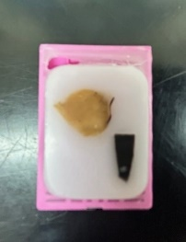**END PRODUCT**- Each cassette (and all of contents) = 1 block = 1 section

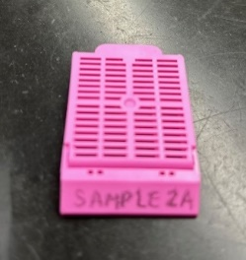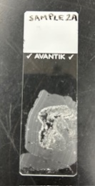

* **SECTION THICKNESS-** Sections are cut at a standard 4-5µm.
* **FROZEN SECTIONING-** Frozen sectioning is unavailable.
* **ORDERING-** What preparation or tests are you ordering? Please make this clear on the submission form.

Here are some examples:

* + - Submitting 30 cassettes- would like 60 slides total- 2 slides stained with H &E for each block.
    - Submitting 10 blocks, would like 2 sections of each block per slide with Trichrome staining.
      * **PLEASE NOTE** this may NOT be possible depending on the size of the sample.
    - Submitting 5 blocks- would like 2 slides for every block- 1 slide with H & E, 1 unstained.
* **COMMENTS & NOTES-** We welcome comments or notes about your samples that you would like to include. Here are some examples:
  + - Frozen tissue sections submitted.
    - Please section at 6 µm.